DS.140 Integration Design Specification



BPA-PO Price Update Integration

SCM_RICE_009

Author: Pranjul Garg

Creation Date: May 22, 2022

Last Updated: Jun 22, 2023

Version: 2.0

**Approvals:**

|  |  |
| --- | --- |
| <Approver 1> | <Rakesh Khanna / Naushad / Amit> |
| <Approver 2> | <Business Owner> |

# Document Control

## Change Record

| Date | Author | Version | Change Reference |
| --- | --- | --- | --- |
| 22-May-2022 | Pranjul Garg | 1.0 | No Previous Document |
| 22-Jun-2023 | Nidhi Siotia | 2.0 | Reviewed |
|  |  |  |  |
|  |  |  |  |

2

## Reviewers

| Name | Position |
| --- | --- |
| FHL Business | Business User |
| FHL IT Group | Fortis IT Team |
|  |  |
|  |  |

Contents

1 Document Control ii

1.1 Change Record ii

1.2 Reviewers ii

2 Introduction 4

2.1.1 Scope for this Document 4

2.1.2 Intended Audience 4

3 Overview 5

3.1 Business Objectives 5

3.2 Major Features 5

3.3 Glossary 5

4 High-Level Fusion Integration flow 6

5 Technical Design Details 7

5.1 OIC Services 7

5.2 Oracle PaaS DBCS components 9

5.3 Technical flow 9

6 Data FIELD Mapping 13

6.1 File format 13

6.2 Frequency 13

7 Exception handling 14

7.1 Scenarios 14

8 Assumptions / Considerations 15

9 Open and Closed Issues 16

9.1 Open Issues 16

9.2 Closed Issues 16

# Introduction

### Scope for this Document

This analysis specification document is prepared to layout the design for an integration to update the line price in BPA & PO based on the changes of list price of a given Item in Item master.

### Intended Audience

This document is intended for the following groups to provide the action items and consideration that are required to complete the implementation of the various Supply Chain and Finance related functionalities from Oracle Fusion.

#### Fortis Business Users

This document will be helpful for Fortis Business users to understand the technical design and process change with the new structure implemented in Oracle. The business user will validate this document after the verification of the requirement.

#### PwC Technical Team

The PwC technical team will use this document as a source technical design document to develop the technical solution to implement / deploy in Oracle Fusion.

#### Fortis IT Team

The Fortis IT Team must facilitate the PwC technical team for requisite details and other elements required from Business. The Fortis IT team is also responsible to arrange and provide required technical information wherever is required.

# Overview

Fortis Healthcare Limited (FHL) is a chain of hospitals, headquartered in India. Fortis started its health care operations from Mohali where first Fortis hospital was started. Later, the hospital chain purchased the healthcare branch of the Escorts group and increased its strength in various parts of the country. The Fortis health care also operates its hospital in Vasant Kunj, Faridabad, Gurgaon. The FMRI hospital at Gurgaon is the headquarter of Fortis healthcare with all the major facilities at the hospital.

This specification document is prepared to layout the design for an integration to update the line price in BPA & PO based on the changes of list price of a given Item in Item master

## Business Objectives

The following are the business objectives.

1. To have a secure, reliable, and scalable design flow to fetch the eligible records of BPA & PO to update the price.
2. To have a solution providing the monitoring capabilities.

## Major Features

The proposed solution will have the following features involved:

1. For PO price update, OIC integration invokes Fusion BI report to fetch the eligible data and then updates the PO line.
2. For BPAs, it’s been built in PaaS DBCS & OIC both.

## Glossary

REST

Representational State Transfer.

OIC

Oracle Integration Cloud

# High-Level Fusion Integration flow

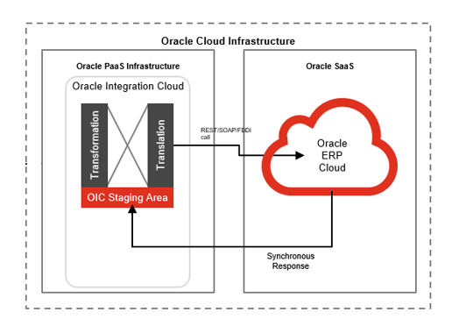

# Technical Design Details

This section describes the technical details of all the components involved in the design for an integration to update the line price in BPA & PO based on the changes of list price of a given Item in Item master.

## OIC Services

An App driven orchestration has been designed in OIC to build a REST Endpoint URL for PO Line price update functionality:

|  |  |
| --- | --- |
| **OIC Integration Name** | Fortis Trigger PO Line Price Update Integration |
| **OIC REST Endpoint URL** | <https://oic-prod-nr5lr39yailj-bo.integration.ocp.oraclecloud.com:443/ic/api/integration/v1/flows/rest/FORT_TRIG_PO_LINE_PRIC_UPD_INTG/1.0/po/linePriceUpdate/> |
| **Method** | POST |

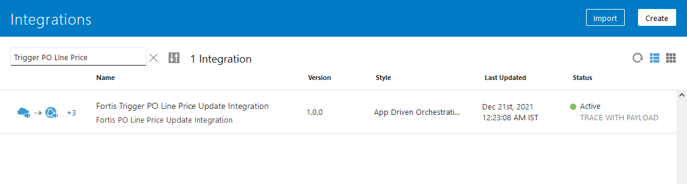

This is an app driven integration which is invoked via a following common scheduled OIC integration:

|  |  |
| --- | --- |
| **OIC Integration Name** | Fortis Trigger 30m Integration |
| **OIC REST Endpoint URL** | [NA](https://oic-prod-nr5lr39yailj-bo.integration.ocp.oraclecloud.com:443/ic/api/integration/v1/flows/rest/FORTIS_TRIG_GRN_PUT_AWAY_TXN_INT/1.0/grnPutAway/) |
| **Method** | NA |
| **Frequency** | Scheduled every 30 minutes |

This wrapper scheduled integration has been configured due to the limit of scheduled integrations within OIC. Hence all the required scheduled integrations have been clubbed together as per their required frequency.

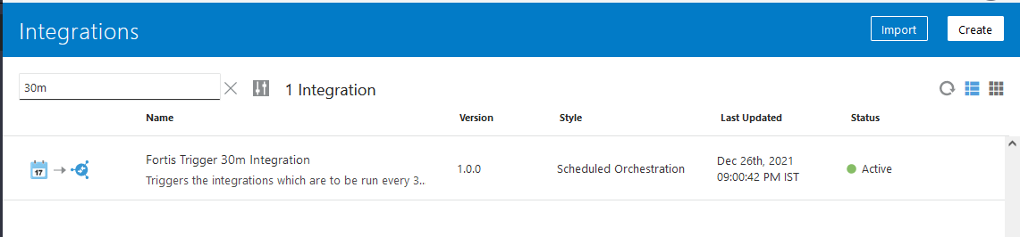

For BPA line price update, following OIC integrations have been developed.

1. A scheduled OIC integration is configured which triggers a PLSQL procedure in PaaS DBCS and then invoke another app driven orchestration to process the BPA price update.

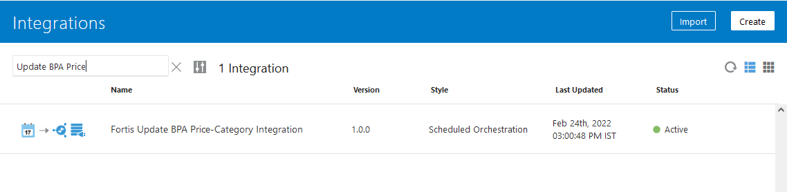

1. Following App driven orchestration is invoked from the above scheduled integration to process individual BPA to update via FBDI process.

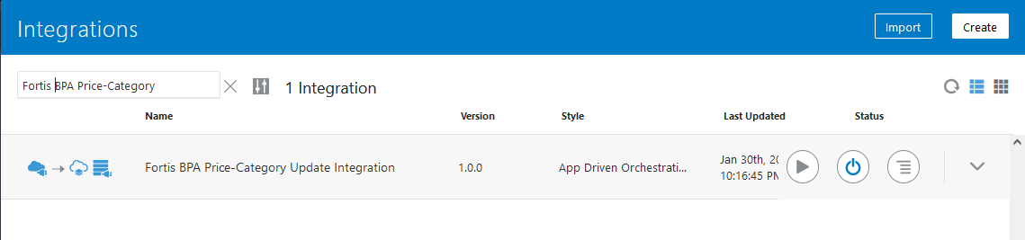

## Oracle PaaS DBCS components

This integration design uses the following DBCS related components:

|  |  |  |
| --- | --- | --- |
| **DB Component** | **Component name** | **Details** |
| **Tables** | XXFH_BPA_HEADERS_UPD_TBL | This table is used for BPA price & category update functionality. |
| XXFH_BPA_LINES_UPD_TBL | This table is used for BPA price & category update functionality. |
| **Package** | XXFH_BPA_UPDATE_PKG | This package is used to process the BPA where price or category needs to be updated. |

## Technical flow

**PO Line price update integration:**

Following is the complete technical flow for this integration design:

1. A common scheduled OIC integration (Fortis Trigger 30m Integration) invokes this integration to update the PO line price.
2. The OIC integration invokes ESS Job: Fortis PO Line Price Update ESS Job (path: /oracle/apps/ess/custom/purchasing/po_line/) which internally invokes BI Report: Fortis PO Line Price Update Report to fetch the eligible PO line records where price needs to be updated.
3. This BI report uses the following query to fetch the eligible records.

SELECT pha.po_header_id,

pha.segment1 order_number,

pha.prc_bu_id,

pha.soldto_le_id,

pla.po_line_id,

pla.line_num,

pla.line_type_id,

esi.list_price_per_unit

* ( ( 100

- NVL (

(SELECT discount

FROM PO_HEADERS_ALL pha1, PO_LINES_ALL pla1

WHERE pha1.po_header_id = pla1.po_header_id

AND pla1.from_line_id = pla.po_line_id

AND pha1.TYPE_LOOKUP_CODE = 'BLANKET'),

0))

/ 100)

unit_price,

CASE

WHEN pda.quantity_delivered = 0

THEN

'Unit Price Update'

WHEN pda.quantity_delivered >= 1

AND pda.quantity_delivered < pda.quantity_ordered

THEN

'PO Line Close'

END

action,

'BPA PO Line Close' KEY

FROM PO_HEADERS_ALL pha,

PO_LINES_ALL pla,

PO_DISTRIBUTIONS_ALL pda,

EGP_SYSTEM_ITEMS_B esi,

INV_ORG_PARAMETERS iop,

HR_ORGANIZATION_UNITS hou

WHERE 1 = 1

AND pha.po_header_id = pla.po_header_id

AND pla.po_header_id = pda.po_header_id

AND pla.po_line_id = pda.po_line_id

AND pda.quantity_delivered <> pda.quantity_ordered

AND pha.TYPE_LOOKUP_CODE = 'STANDARD'

AND pha.document_status NOT IN ('INCOMPLETE', 'CLOSED')

AND pla.from_line_id IS NULL

AND pla.from_header_id IS NULL

AND NOT EXISTS

(SELECT 1

FROM po_headers_draft_all phda

WHERE phda.po_header_id = pha.po_header_id

AND phda.entity_change_type_code IN ('U', 'C')

AND phda.prc_bu_id = pha.prc_bu_id)

AND pla.item_id = esi.inventory_item_id

AND pla.prc_bu_id = iop.business_unit_id

AND esi.organization_id = iop.organization_id

AND iop.organization_id = hou.organization_id

AND hou.name LIKE 'DTH%'

AND pla.unit_price <> esi.list_price_per_unit

AND esi.inventory_item_status_code = 'Active'

AND esi.approval_status = 'A'

AND EXISTS

(SELECT 1

FROM EGO_ITEM_EFF_B eieb

WHERE esi.inventory_item_id = eieb.inventory_item_id

AND esi.organization_id = eieb.organization_id

AND eieb.category_code IN ('Pharmaceuticals',

'Medical_Consumables')

AND eieb.CONTEXT_CODE = 'Pricing'

AND NVL (eieb.ATTRIBUTE_CHAR3, 'N') = 'Y')

1. The above query fetches the PO line where the item is either a PH or MC item, it’s a margin controlled item as per Item master and has a price difference between PO line & item master.
2. This OIC integration then invokes the following SOAP web service for changePurchaseOrder operation to update the unit price at PO line for each & every record:

|  |  |
| --- | --- |
| WSDL URL | <https://fa-ermg-saasfaprod1.fa.ocs.oraclecloud.com:443/fscmService/PurchaseOrderServiceV2?WSDL> |

**BPA Line price update integration:**

Following is the complete technical flow for this integration design:

1. A scheduled integration: Fortis Update BPA Price-Category Integration is scheduled at every 20 mins of frequency.
2. This integration first invokes a procedure from PaaS DB: XXFH_BPA_UPDATE_PKG.XXFH_BPA_UPDATE_PRC to fetch the eligible records where either price mismatch exists between BPA line & Item master or there is a category mismatch.
3. To keep the performance intact, the code checks for the item records from Item master which have been updated in the last 5 days and checks for respective “OPEN” BPA lines where the price or category mismatch exists.
4. Once the data is identified & fetched, it is inserted into tables: XXFH_BPA_HEADERS_UPD_TBL (for header data) & XXFH_BPA_LINES_UPD_TBL (BPA lines data) & xxfh_bpa_line_locs_upd_tbl(BPA line location data)
5. The data into these 3 custom tables is entered in a way which s required to write in the FBDI file.
6. For Price update request, the same BPA line with new price must be put with action as UPDATE.
7. For Category update, it requires 2 rows to be inserted. One row for the existing record with expiry date to expire the existing line and 2nd record is for addition of new line with the latest category.
8. Once this procedure completes, OIC further fetches the distinct PRC_BU_ID & AGENT_ID combination from XXFH_BPA_HEADERS_UPD_TBL because the FBDI runs based on these parameters and hence the FBDI process needs to run in loop for such multiple combinations.
9. For each such combination, it invokes another child OIC integration: Fortis BPA Price-Category Update Integration to fetch the eligible records from XXFH_BPA_HEADERS_UPD_TBL , XXFH_BPA_LINES_UPD_TBL & xxfh_bpa_line_locs_upd_tbl for a given combination of PRC_BU_ID & AGENT_ID, create the FBDI file and invoke seeded ESS job (Load Interface File for Import & Import Blanket Agreements) to import these updates in Oracle fusion.
10. Once Import Blanket Agreements ESS job processes the BPA updates, it creates a CO on that BPA in Fusion. This CO is then processed via PaaS approval validation functionality and once the CO is validated successfully, it gets approved, and the changes happen in the BPA.
11. If by any chance, the BPA has a CO already, then the new CO from Import Blanket Agreement cannot be created as Oracle doesn’t support parallel CO. In such case, user has to cancel the existing CO and then the next scheduled run of this integration will again try to create the CO.

**Server details:**

|  |  |  |  |  |
| --- | --- | --- | --- | --- |
| **Server** | **Host name** | **Port** | **Service Name** | **Username** |
| Oracle PaaS DB | 140.238.225.129 | 1521 | PRODPDB1.fhpubsn.fhvcn.oraclevcn.com | XXFH & XXFH_RO |





# Data FIELD Mapping

NA

## File format

NA

## Frequency

The integration is scheduled to run every 30 minutes.

# Exception handling

There can be various scenarios for an error to occur. This section defines those error scenarios, and the exception handling has been done to notify and act accordingly.

## Scenarios

In a tabular format give list of scenarios and exception handling

* If any of the step or node fails within the OIC integration, Global Fault section is configured within this OIC integration to send an OIC error notification with relevant details.
* The email id has been stored in OIC Lookup: Fortis_FaultNotification_EmailAddress_Lookup against the given OIC integration name.
* It also sends a notification whenever integration processes any data. This notification also acts as a confirmation that the integration has been running fine.

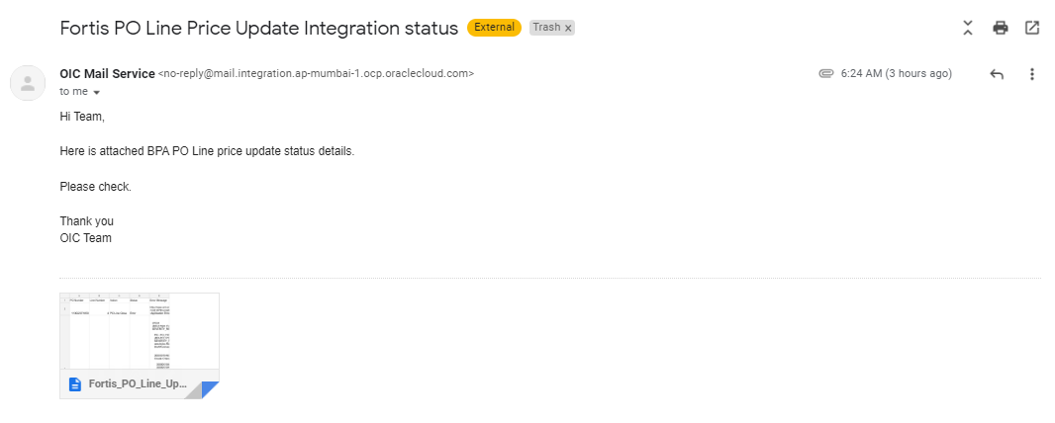

# Assumptions / Considerations

The Proposed Solution will have the following technical considerations.

In the future, if any product bug arises in functionality then this process needs to be revisited after the bug is fixed.

# Open and Closed Issues

## Open Issues

| ID | Issue | Resolution | Responsibility | Target Date | Impact Date |
| --- | --- | --- | --- | --- | --- |
|  |  |  |  |  |  |
|  |  |  |  |  |  |
|  |  |  |  |  |  |
|  |  |  |  |  |  |

## Closed Issues

| ID | Issue | Resolution | Responsibility | Target Date | Impact Date |
| --- | --- | --- | --- | --- | --- |
|  |  |  |  |  |  |
|  |  |  |  |  |  |
|  |  |  |  |  |  |
|  |  |  |  |  |  |